**Lesson 9: Probability**

**Do Now:**

6

9

7

6/12 or ½

7/12

4/12 or 1/3

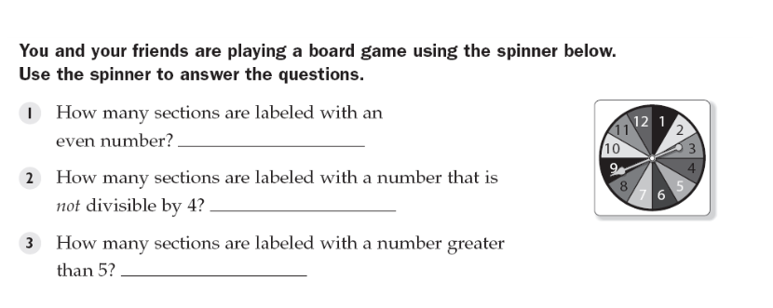

**4. What is the probability that I land on an even number?**

**5. What is the probability that I land on a number greater than 5?**

**6. What is the probability that I land on an even number that is also greater than 5?**

**Key Vocabulary:**

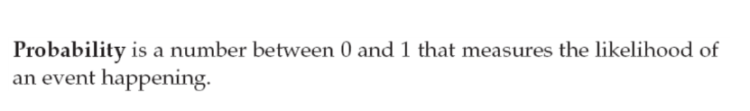

**An outcome is a possible result of a probability experiment. For example, getting a heads from a flip of a coin is an outcome.**

**An event is a set of outcomes. For example, “getting an even number” is an event that includes the outcomes of 2, 4, and 6 from a roll of a die.**

**Guided Notes:**

**ERIC’S VIP FOR PROBABILITY**

**\*\*\*ASSUMING ALL OUTCOMES ARE EQUALLY LIKELY\*\*\***

1. **Draw your *sample space*. Your sample space includes all the possible outcomes. Make sure every outcome is accounted for, even if it’s highly unlikely. The number of outcomes is your denominator**
2. **Count the number of possibilities of the event you desire (the possibilities of what you are looking for). That number is the numerator**
3. **Simplify fraction. That fraction should be between 0 and 1, inclusive, or you did something wrong!**

**Example 1: Find the probability that you get a heads from a flip of a fair coin.**

**1. Sample space is {H, T}: you can either get heads or tails. There are two outcomes, so that’s the denominator.**

**2. The only possibility we want is H. That’s one outcome. That’s the numerator.**

**3. Answer is ½.**

**Example 2: Find the probability that you get two heads from two flips of a fair coin.**

1. **Sample space is {HH, TH, HT, TT}: either two heads, tails then heads, heads then tails, or two tails. Four possibilities.**
2. **Only one desired outcome: HH.**
3. **Answer is ¼.**

**Example 3: Let’s say I roll a fair dice and flip a fair coin. What is the probability that I get an even number and heads?**

1. **Sample space: {1H, 2H, 3H, 4H, 5H, 6H, 1T, 2T, 3T, 4T, 5T, 6T}. There are 12 possibilities.**
2. **The desired outcomes are here: {2H, 4H, 6H}. Three possibilities**
3. **Answer is 3/12, or ¼.**

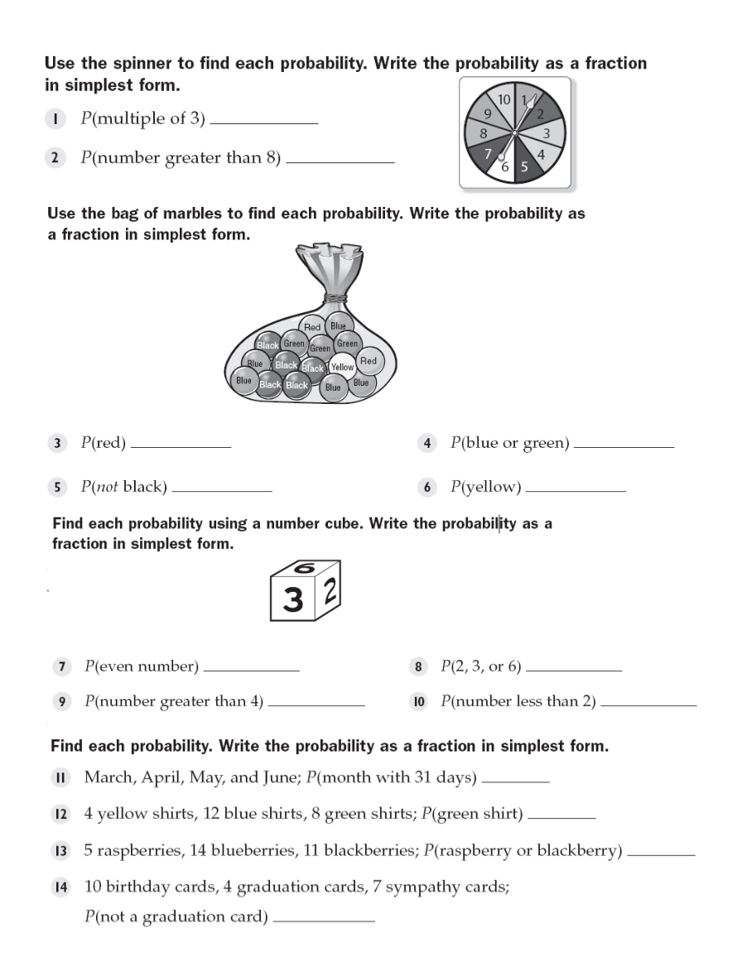

3/10

2/10 or 1/5

1/8 ½

11/16 1/16

½ ½

1/3 1/6

½

1/3

8/15

17/21

**Structured/Guided Practice:**

½

4/11

1/5

7/15

11/15

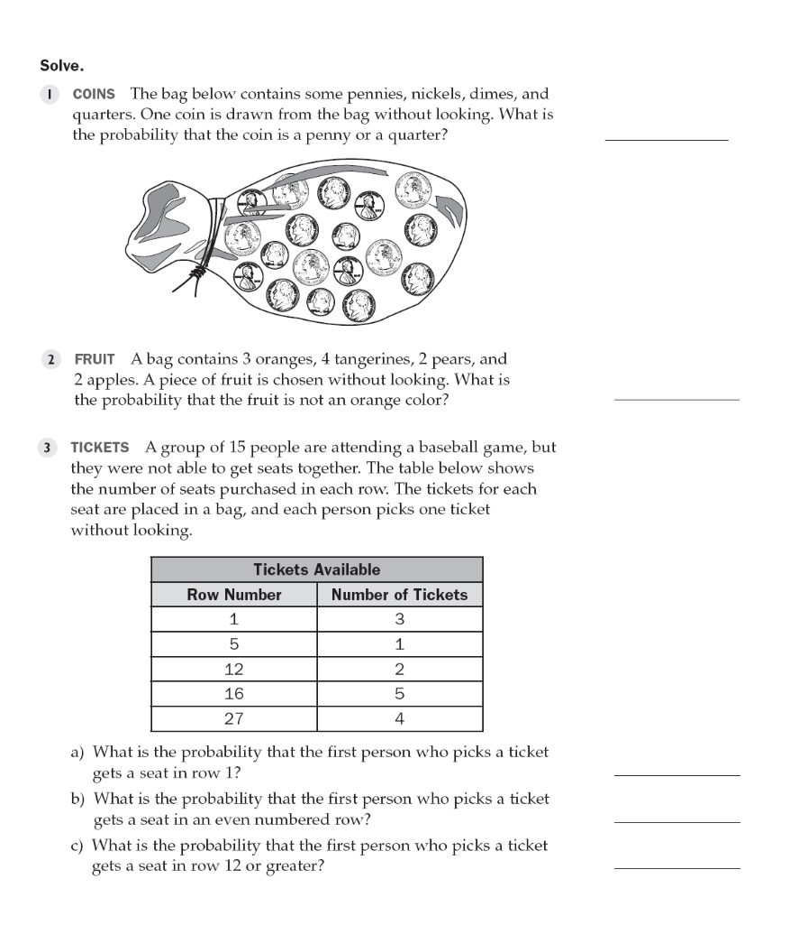

**Independent Practice:**

½

¾

3/10

4/5

½

½

7/12

1/3

outcome

fraction

event

Probability

